(Approx. 1613 words)

Creating a Newsletter with Writer
By Joel Ewing, President, Bella Vista Computer Club, AR
October 2017 issue, Bits & Bytes
www.BVCompClub.org
president (at) bvcompclub.org
There are software applications designed explicitly for creating formal publications, but many small organizations don’t require newsletters with highly professional formats, and secondly, many such groups depend on volunteer editors who lack the time to produce such a document, even if they were able to afford the software.

The purpose of this article is to demonstrate that a few simple techniques with a completely-free, open-source word processor, LibreOffice Writer, can be used to create a newsletter in 8.5x11 format which looks reasonable with minimal effort. These same techniques could, no doubt, be applied using MS Word, since there is considerable overlap in functionality between MS Word and LO Writer, despite major differences in the user interfaces. But, if the object is to encourage someone who might not have access to MS Office to become an “editor,” the availability of free alternatives is a definite plus.

The most common newsletter format is to have a full-width header at the top of the first page, followed by content on that and following pages. Many people seem to find it easier to visually follow an article that is not full-page width, so typically the article content uses a multi-column format with two or more columns. There is multi-column-format support in LO Writer and also support for “frames”, which facilitates creation of a header that follows different conventions.

My personal preference is to go with two columns for content. Dividing into more than two columns complicates fitting larger images within an article, and makes it more likely that long words or long URLs will cause visual problems with line justification and line splits.

The Header
This is the place to start. Although it will take some experimentation and time to create, this is also the part of the Newsletter that will be relatively constant, with possible exception of date, and can be cloned for future Newsletters. I like the header to dominate and be a little wider than the default margins. I find a width of 7.65” will still print reliably, but you may want to verify that width will work if you have a specific printer you use to make hard copies of the Newsletter.

Start with a blank document. Then Insert→ Frame…
- Type: Set Width 7.65”
- Height “Autosize
- Position Horizontal “Center”
- Vertical “Top”, Anchor “To page”
- Borders: “all”, Line Width “1.0 pt. (adjust to taste-- you may want to adjust “Spacing to Contents” as this determines the light-gray inset from the borders where heading contents may be placed)
- Area: may want to adjust Fill later
- Columns: should default to “1”. This will give you an empty frame, almost full-page width, high enough for one line of text, but it will expand as content is added.

Start typing information into the frame. Which lines come first, font used, font size, left-right alignment are variable and subjective. This text should include Title, various organization information, date of newsletter, etc. Keep text that you might want to position/size separately as separate paragraphs (followed by “Enter”). Just keying in the basic information using default font and size choices gives the result that follows – not particularly impressive.

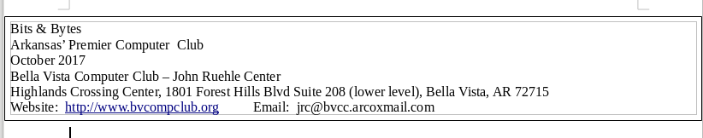
Now comes the experimentation part – trying out different fonts, font sizes, font effects (bold, shadow, etc.) until you find some combinations that appeals to you. Starting from nothing may take some false starts and an evolving design. In my case I was trying to come as close as possible to some historical versions of the Newsletter that had been produced with other tools, and used those as a guide. I finally settled on:
- Title: “URW Chancery L” size 60, bold, with shadow
- 2nd line “Liberation Sans”, size 11’
- Date: “Liberation Sans”, size 24, bold;
- Bella Vista… line: “Liberation Sans” size 14, bold;
- Highlands… line: “Liberation Sans” size 11, bold
- website line: “Liberation Sans” size 10
After right-justifying the date and adding several trailing blanks, and centering the next two lines, this gave the effect:
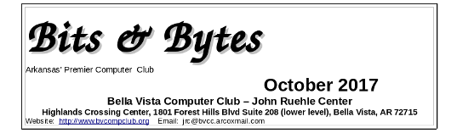

On the final line, I want the Website left justified and the Email right-justified, which can’t be done automatically. The simple solution is to insert enough blanks to put the Email in the desired location. This is getting close. I would like to have just a little more space above the Website line. Select that line and format the paragraph: add 0.06 spacing above the paragraph.
We have an image that normally goes in the upper right corner of the heading that has black lines on a white background. Set the cursor at the end of the Title and insert the image. It won’t go in the right place, but manually click and drag it to the upper right corner of the heading frame. To make things slightly more elaborate you can choose to modify the “Area” properties of the frame to include a light color fill, or in our case we have a lightly-colored bitmap background of our logo that we use on the web site which can be specified, resulting in the following:
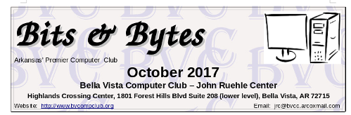
Notice the white rectangle background around the image is not what was intended. We need to instead use a version of the image where all the white areas are transparent. This can be done easily with the free GIMP image manipulation utility (a tale for another day), by selecting all the white areas, inverting the selection, copying the selected pixels, pasting as a new image and exporting that as a PNG image. Deleting the original image from the heading frame and inserting the new version gives us the final version shown below. The fine guide lines showing the borders of the image will not be in printed or PDF versions of the document.
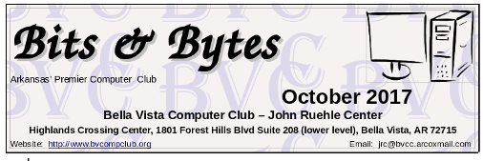
As one final observation on the header, the easiest way to update the Date in the header without upsetting the formatting is to insert the cursor somewhere in the middle of the existing date (to get the same formatting) type the new date, then deleted the unwanted characters from the old date. If you delete the old date first, you will likely have to re-do all the font and size customization that was done for the date.

The Content
- Set the cursor below the heading frame, right click, select Page…,
- Set the Page Style for left/right margins of 0.75” (or possibly as low as 0.5”)
- Set Columns to “2”. I like a black Separator Line of 0.25pt, but that’s personal preference. You should probably also set a “Spacing” of at least 0.1” between columns to get some visual separation.

Articles may either be copied and pasted from some other source or manually typed into the newsletter starting with the left column. I would recommend using a consistent article heading style and a consistent font type and size – although it is sometimes useful to play with inter-line or inter-paragraph spacing, and perhaps even with font size to get an article to fit in the available space.

I would find a heading style that is close to what you want for article headings, modify the style to force the desired font, font size, and other heading options, and then consistently use that style for all headings.

For separating articles, I would recommend inserting a horizontal line (Insert → Horizontal Line). The action name is a little misleading because what it actually does is mark the current paragraph with a “horizontal line” style which causes the paragraph to have a bottom border drawn. That style can also affect paragraph font and size and line spacing, which is not usually what you want for a paragraph of text. So, the proper usage of the horizontal line (from painful experience) is: at the end of an article, press Enter, type one space (to get a non-visible paragraph of one space), and then Insert the Horizontal line at that point so it the bottom of that invisible “space” paragraph. You can edit the “Horizontal Line” style to increase the width of the horizontal line (it is the bottom Border) to make it more pronounced or a different line style, and you can adjust the amount of vertical space before and after the “Horizontal Line” paragraph.

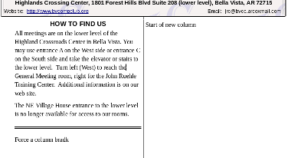
If you want to begin work on the right column of a page before finishing the left, or if you just want to force the column break to occur at a better separation point, you can use Insert → Manual Break… and select “Column Break.” You can similarly use Insert → Page Break to force text to begin a new page before the current page is full.

Working with articles with images can be tricky, because LO Writer likes to “anchor” the images to a paragraph which can limit how it can be moved. If necessary you can alter the properties of the image to change how it is anchored. When the image is selected, the anchor point is displayed (an anchor icon) and it may be moved to a different point in the article. Sometime attempting to move the image makes it fly to unexpected locations or even disappear, at which point “undo” is your friend. You can find many suggestions on-line about how to deal with images in Writer, but none of the solutions are very elegant or foolproof.

Experience with this article showed that copying and pasting a single-column document into a two-column target does not handle embedded images well. You are better off saving the images separately, deleting any images copied with the document, and manually re-inserting the images at an appropriate point so that they get properly sized for the narrower columns.

